Imagine the web as a giant conversation. Websites are like different locations in this conversation, each built with specific tools. Web tech is like the language everyone uses to understand each other and build these virtual spaces.

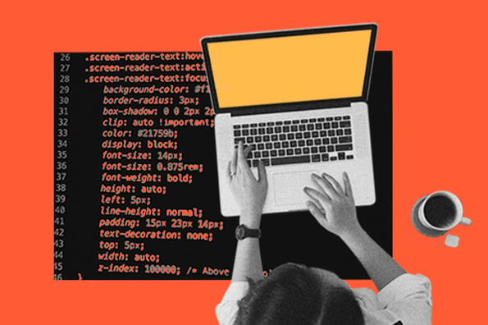

There are two main parts to web tech: front-end and back-end. The front-end is what you see and interact with on a website, like text, images, and buttons. It's like the shop window you see on the street. HTML, CSS, and JavaScript are the most common tools for building this shop window. HTML creates the basic structure, CSS styles it with colors and fonts, and JavaScript makes it interactive.

The back-end is the hidden part of the website, like the storeroom behind the shop window. This is where information is stored and processed. There are many tools for back-end development, but some popular ones include languages like Python and Java.